Drive Maintenance
- Defrag the Hard Drive
Snip of the PRE Defrag Drive | 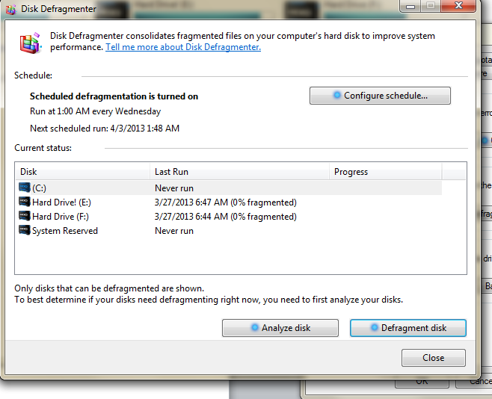
Snip of the PoST Defrag Drive | 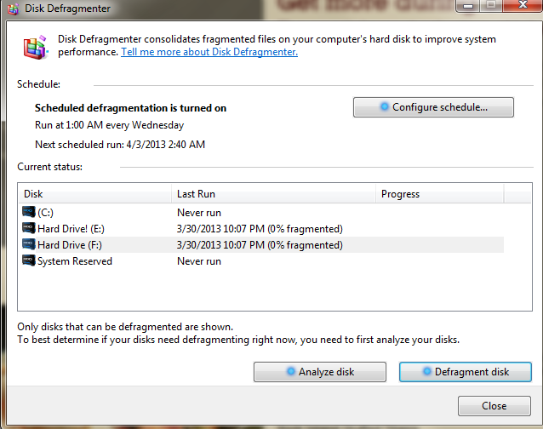

- Disk Clean Up Run the Disk Clean Up Utility
Insert Snip of Disk Clean Up screen | 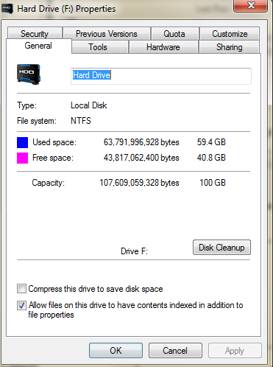
How much Space can you gain? | 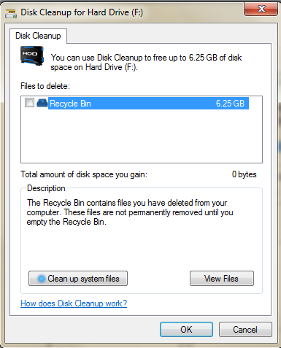
Which Kinds of files will you delete (you don’t have to delete any)? | Media- videos pictures music unused programs

- CHKDSK
  - Access the command prompt
How did you get to the command line?
Start > search box > cmd.exe > enter
  - Run CHDSK /R
What does the /R do?
Restart the local computer

